Use-Case Realization Report (Requirements)
Refund Money

Issue 3.0
Revision History
Date | Issue | Description | Author
13 July 2000 | 1.0 | First Issue | Howard Russon
20 July 2001 | 2.0 | Revised for MTech Unit 3 in 2001 | Howard Russon
22 July 2004 | 3.0 | Revised for MTech Unit 3 in 2004 | Howard Russon

Table of Contents
1. Brief Description 4
2. Flow of Events 4
2.1 Standard Flow 4
2.2 Exceptions 4
3. Interaction Diagrams 5
3.1 Domain Collaboration Diagram: Refund Money 5
4. Participating Objects 5
5. Class Diagrams 6
5.1 Domain Class Diagram: Refund Money 6
6. Derived Requirements 7

Use-Case Realization Report
Refund Money

Brief Description
This abstract use case enables refunds of the money entered to be issued to the Customer.

Flow of Events
The standard flow of events for this use case and any exceptions are described in the following subsections. See section 3.1 for an overview of the participating Actors and Domain Objects.

Standard Flow
This use case is used by use case Coin Input and Select Brand to refund entered Coins as follows:
- If the drinks can has not yet been dispensed, then the Customer will be able to terminated the transaction, if required, by pressing the button with the caption “Terminate and Return Cash” on the Customer Panel.
- The system will then determine the amount of money that has been entered.
- In the real vending machine, the Coins will then be sent to a cash tray built into the Customer Panel. In the computer simulation, the value of the returned money will appear in a panel next to the caption “Collect Coins”.
- The internal record of the coins entered for the current transaction will then be reset to zero.
- The system will then be ready for the next customer transaction.

Exceptions
The following exceptions have been identified:
- No Coins Entered. If zero Coins have so far been entered during the current transaction, then refund requests will be ignored.
- Terminate Request Too Late. If the terminate request is made after the dispensing of the drink has commenced, then the request will be ignored.

Interaction Diagrams

Domain Collaboration Diagram: Refund Money
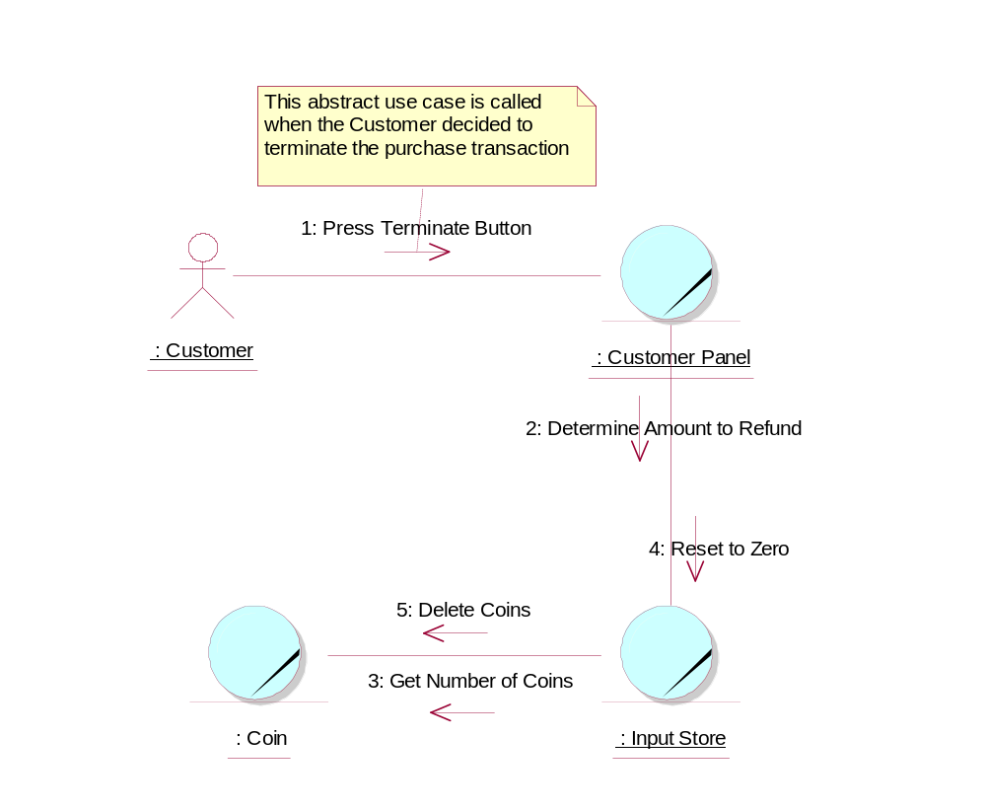

Participating Objects
: Coin
The object stores the characteristics of coins entered into the system.
: Customer
This actor represents the customer of the vending machine (members of the general public) who would buy drinks-cans from the vending machine.
: Customer Panel
This panel simulates the vending machine's customer interface panel. It will enable the user (the Customer) to:
1 insert coins;
2 select brands;
3 terminate transaction.
It will also provide the following display functions:
1 display total money inserted;
2 indicate coin not valid;
3 indicate no change available;
4 display the value of the change to be collected;
5 display an icon representing the dispensed drink.

: Input Store
When Coins are entered into the Customer Panel, they are initially held in this store until the correct amount of money has been entetred by the Customer.

Class Diagrams

Domain Class Diagram: Refund Money
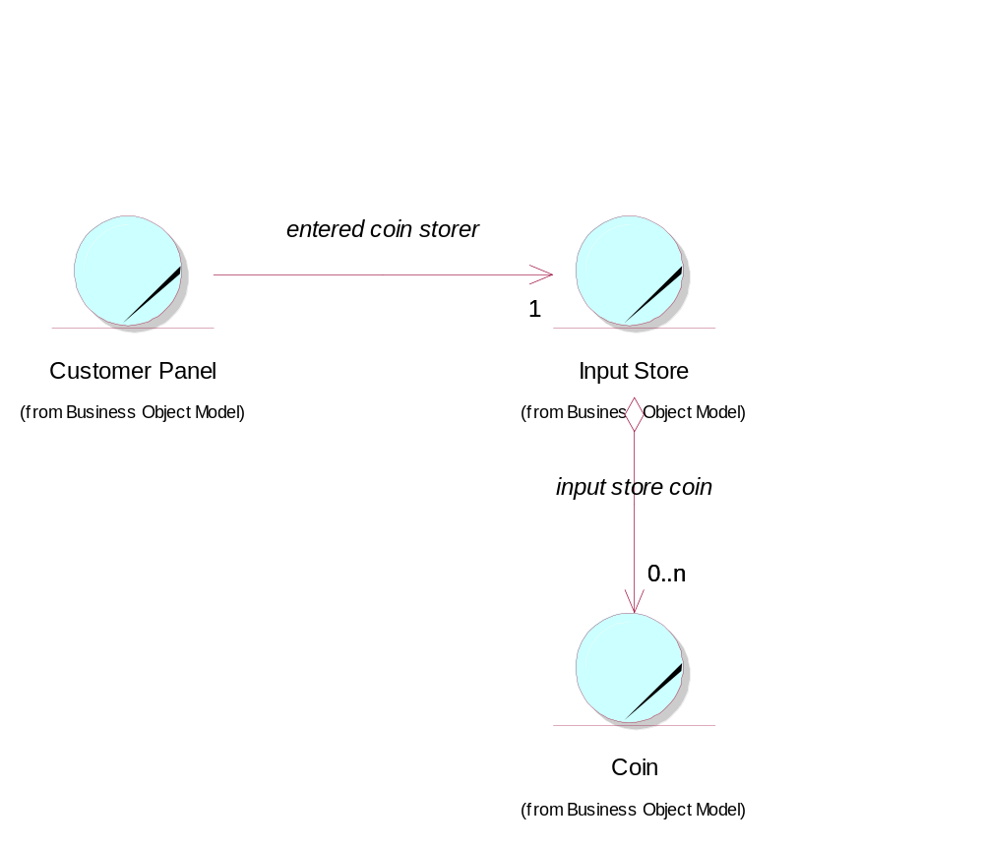

Derived Requirements
In the real vending machine, a cash tray is required to be built into the Customer Panel.

